

American International University-Bangladesh (AIUB)  
**Department of Computer Science  
Faculty of Science &Technology (FST)  
Summer 19_20**

**Section: A   
Group No: 04**

**Plasma Tracker**

A software Engineering project submitted

By

|  |  |  |
| --- | --- | --- |
| SN | Student Name | Student ID |
| 1 | Barua, Diganta | 18-36262-1 |

The project will be Evaluated for the following Course Outcomes

|  |  |
| --- | --- |
| CO3: Choose appropriate software engineering model in a software development   environment | Total Marks |
|  |
| Project Background Analysis (problem, needs, goal, benefits, etc.) [5Marks] |  |
| Appropriate Process Model Selection and Argumentation with Evidence [5Marks] |  |
| Completeness, Spelling, Grammar and Organization of the Answer [5Marks] |  |
|  | |
| CO4: Explain the roles and their responsibilities in the software project   management activities | Total Marks |
|  |
| Content Knowledge (e.g. System Requirements, System Design) [5Marks] |  |
| Project Role identification and Responsibilities descriptions [5Marks] |  |
| Presentation Delivery and Defense [5Marks] |  |

**Text Format:**

* Style: Times New Roman
* Size: 12
* Line spacing: 1

**Exercise -1**

**Introduction:**

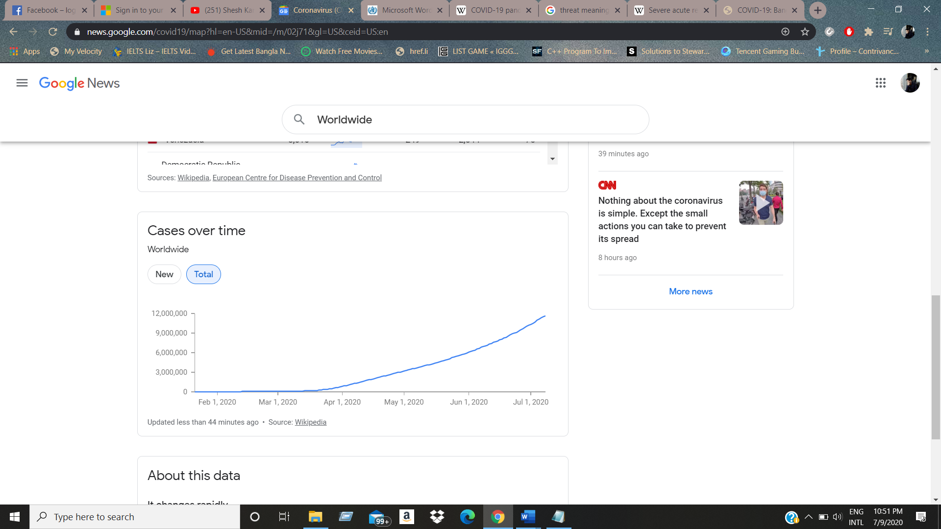Corona Virus Pandemic (formality known as COVID-19 pandemic) caused by severe acute respiratory syndrome coronavirus 2 (SARS-CoV-2) is now became a global threat for all across the world. This global threat first allocated in Wuhan, China on 11 Mach, 2019.The World Health Organization declared this as an outbreak on 30 January and a pandemic on 11 March As of 9 July 2020 because of more than 12 Million cases form 188 countries across the world which was caused by this virus. The number of affected people and affected countries is still increasing.

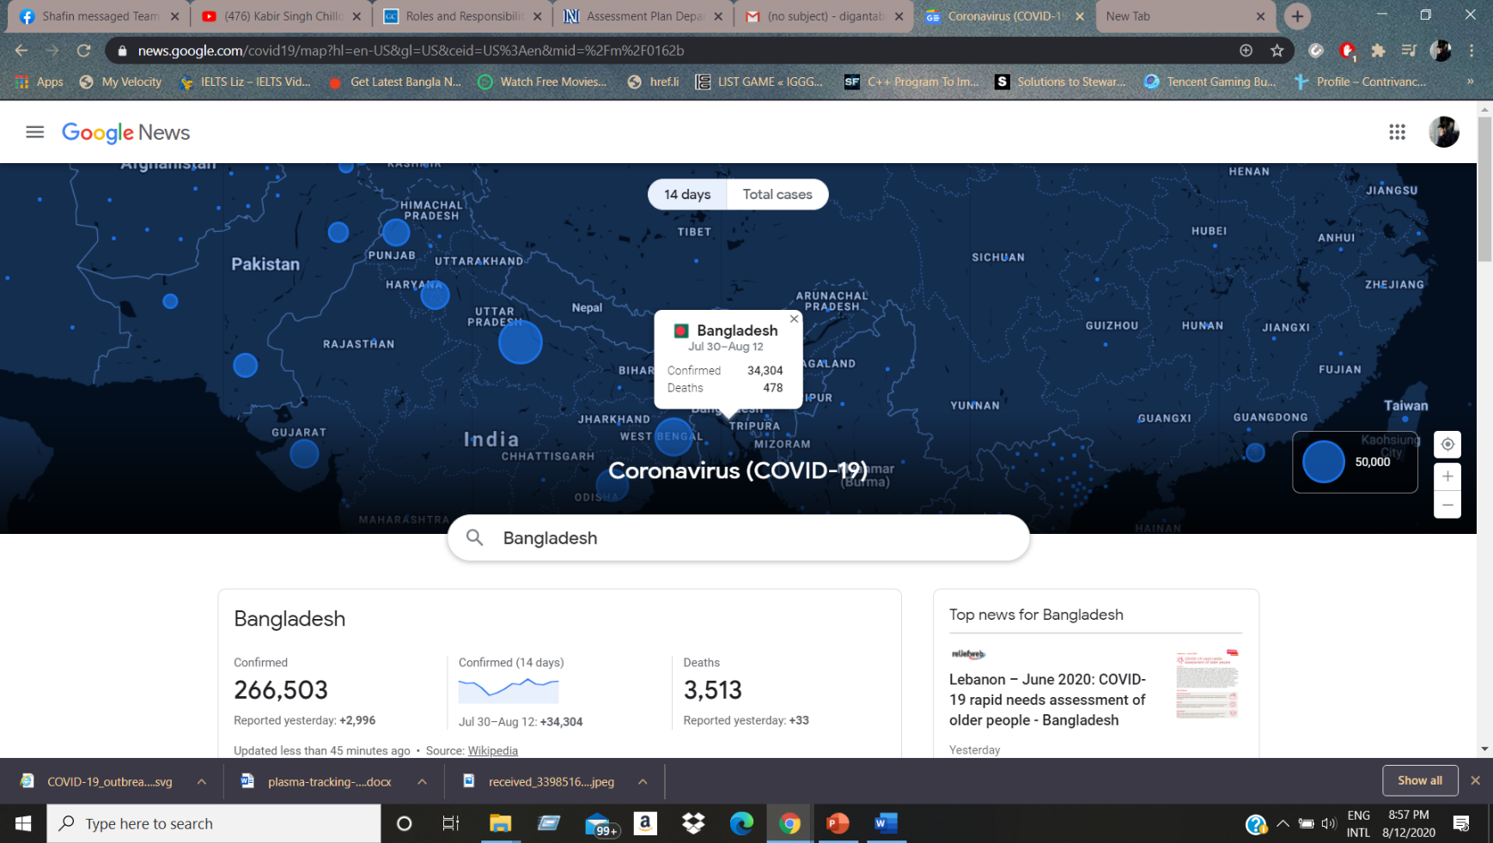 The virus was confirmed to have spread to Bangladesh in March 2020. The first three known cases were reported on 8 March 2020 by the country's epidemiology institute, IEDCR.

The problem is so important to consider because it can transmit from human to human by coughs and sneezes with a range of about 1.8 meters and the vaccine of this virus is still under development. But people are taking Plasma treatment around the world Which is showing a surprising result to cure the Covid affected peoples. Like other countries Bangladesh also exploring the plasma treatment as a ray of hope.

* Q1. Does the team demonstrate a thorough understanding of the need, problem, or opportunity, including evidence of research into the need, problem, or opportunity?

Bangladesh listed as Covid-19 affected country in March 2020 with three known cases and now the number is 172,134+ with 2,197+ deaths. The number is increasing dramatically this virus can transmit from person to person easily and the vaccine of this virus is still under development. So, people should have to be more aware of it. As Bangladesh is a developing country with a rate of population and illiteracy that making the affected number increasing. Since the vaccine is still under developing the world health’s organizations claimed that plasma from those patients who got cured from Covid-19 can be used instead of vaccine. And it shows and magnificent result to cured the Covid affected people.

* Q2. Does the project have a clear objective including relevant benefits an target market or audience of the product?

Bangladesh is leading 17th position country in Covid-19 virus. Still it’s vaccine in under developing. In Bangladesh perception it’s a most relevant beneficial project. Cause in a country like Bangladesh huge number of case’s so far and the ongoing treatment is plasma injecting people need plasma from those victim’s patient who are safe. So tracking those people is tough. Project like Plasma Tracker will help people to track down those people who can give or available to donate plasma. Thus, it will save the time and also seeker don’t have to worry about source and its security. Whenever people will see that they don’t find any difficulty to find plasma, then they will definitely be going to pay their interest on it. By building an application to stored data of plasma information, location, information and reviling it on play store, apple Store can help the project to reach out to the user or the seekers. So basically, the targeted audience for this project are those who needs plasma in a well-organized secure source. Moreover, most of them in us using android mobile who already know how to use application, so that case targeted people easily can use it, also we can develop Bangla language that also help who face some difficulty in English. Also, we can contact Health ministry to inform about our project that how can or how much it beneficial in our country that they collaborate with us to build up this.

* Q3. What are the solutions you are going to propose to deal with the problem? why is this solution is particularly appropriate to solve the problem? Is the solution feasible to the meet the business objective?

As we know that Bangladesh is now listed a covid-19 affected country. The Solutions are going to be like collecting plasma from the recovery patient and listed into a secure management system then provide it to the affected patient. Now telling elaborately, firstly Wesaw that the Manuel collection of plasma sample is not effective because the affected patient does not know about the collector properly and the sometimes it is too hard to maintain the list. So, we want to build a system that if a recovered patient donate plasma then He can be registered into our system by nid or passport. Then we can list the plasma blood group, when he was recovered, how long he was suffering he can donate plasma. The arrival of Covid-19 vaccine is not so soon so. we need built a system that can help the critically effected people. The business purpose is that when we are collecting the information of client then we can use it in other government project in near future for the betterment economy. The government can play in the field of unemployment challenge for the people whom need job. The government can do a project for the women empowerment. The list also can help the education sector above all we can use the data for the health sector.

* Q4. Is the project’s purpose and basic functionality easily understood?

The project’s purpose is basic and functionality easily understandable. According to present crisis, plasma therapy is an experimental treatment that doctors of Bangladesh are using for people with severe coronavirus disease 2019 (COVID-19). The project’s purpose are going to be like collecting plasma from the recovery patient and listed into a secure management system then provide it to the affected patient. Gathering or by tracking plasma info can help people to reach out for the demanded plasma to save life. Whenever people will see that basic functionality don’t find any difficulty to find plasma, then they will definitely put their interest on it. In many cases, Covid-19 patients after recovery are donating plasma for free, while some of them are charging for it. A patient in Kurmitola General Hospital was administered with 400 ml plasma, donated by a person with the help of Bangladesh Specialized Hospital in Shyamoli. In another case, a family collected a bag of blood from a donor for a patient receiving treatment at Anwar Khan Modern Hospital, and had to pay for it. The family declined to disclose the amount of money. It costs Tk 30,000 to administer a bag of plasma at Bangladesh Specialized Hospital. They do it for both inpatients and outpatients. We can build an application that have stored data of plasma info and release it on play store, apple Store so that case targeted people easily can download free app and use it.

**EXERCISE - 2: Requirement Analysis**

**Objective:** Develop a Specification Document of the Proposed Solution

**Tools/ Device:** SRS Template

**Procedure:**

**System Features:**

1. **System login-**

**Functional requirement:**

**1.1->** The system will allow to user to login the system with their valid user-Id or admin-ID and Password.

**1.2->** If the system login successfully then the home page of account holder will be displayed and User can use all features of the homepage

**1.3->** If the user-id or password has been inserting wrong more than five times, then system send a notification also a verification code randomly by mail to user to re-login into system.

**1.4->** If the login attempt number more than 7 time then account will be blocked for 40 minutes, then user can again can re-login into system.

**Priority level:** High.

**Precondition:** Account holder must have valid user-id with valid information.

**Crossover:** 3.1.

1. **Language-**

**Functional requirement:**

**2.1->** System will automatically prefer English language to user.

**2.2->** System allow to User to choose their own prefer language.

**2.3->** After choosing language, user also can change it.

**2.4->** User don’t need to setup every-time language, it will automatically save by system.

**Priority level:** Low.

**Precondition:** User need to login to account first.

**Crossover:** N/A.

1. **System Security-**

**Functional requirement:**

**3.1->** When system will be found anyone try to login unnecessarily many times then system will alert user by sending a message or a mail to user to confirm that is it account holder or not.

**3.2->** User only can able to know their own location, information and donor information (when user need plasma). But system can’t allow to user to change any other user’s or donor information. User only can change his/her information.

**3.3->** Secure all user (seeker, donor, admin) information, that will store in database. And only Admin can access system Database. Database also record all of plasma info that will collect.

**3.4->** After every 60 minutes later, system will automatically logout from system.

**3.5->** If user forget password then user need re-enter his mail address or his mobile number that system can send to user a new password to re-login account. After login user must need to set a new password.

**3.6->** Admin can remove or ban any user from this system for it’s security policy or to prevent treats from unknown networks if necessary.

**3.7->** At a time only one person will be able to login one account.

**Priority level:** High.

**Precondition:** Need to create an account.

**Crossover:** 1.2, 1.3, 1.4,4.3,4.4,5.3,8.1,8.2,10.3,10.4.

1. **Location-**

**Functional requirement:**

**4.1->** User will see a tab in the website can click it and in app there will a location button to

press and both will show a page of location.

**4.2->** User can use filter to select their requirement and search from ticking requirement

needs.

**4.3->** User can search with name of hospital, location, clinic, health center.

**4. 4->** User can go directly to connected map from location page by clicking a hospital tab.

**Priority level:** Medium.

**Precondition:** User have to have a valid account.

**Crossover:** 5.1.

1. **Tracking-**

**Functional requirement**:

**5.1->** User can Track the location of the distance and If the network goes offline it will be

available the last location selected.

**5.2->** User can define the minimum Distance from his location and can measure it by walking vehicle distance.

**5.3->** User can use voice recognition to select the palace and system can deliver some default place of near location.

**5.4->** User can estimate the time from his/her distance by clicking Time duration.

**Priority level:** Medium.

**Precondition:** Location features have to be turned one while using this features.

**Crossover:** 1.2.

1. **Search-**

**Functional requirement:**

**6.1->** User Can search for anything he wants from writing in search bar text it is user friendly box.

**6.2->** User can see some filtering option from the search bar.

**6.3->** User can search by selecting some specific requirement.

**6.4->** User can see some recent result by search tab.

**Priority level:** Medium.

**Precondition:** N/A.

**Crossover:** 11.3,11.4,11.5

1. **Feedback-**

**Functional requirement:**

**7.1->** User can select a feedback tab which a page with comment box show up.

**7.2->** User can select some issue which we will give and there will be other option which user can define his problem.

**7.3->** User can see some feedback of others their he/she can search for his problem.

**7.4->** User can send Photo with his/her issue so that he/she can give his/her explain as he/she wants.

**7.5->** User can remove, edit or update his feedback after submitting by applying to the developers.

**Priority level:** Medium.

**Precondition:** User have to have valid Account.

**Crossover:** 6.5,12.1,.12.2,9.3.

1. **Notification-**

**Functional requirement:**

**8.1->** This system only works if user decide to use it. User control whether user receive exposure notifications, and decide if and when to share their data.

**8.2->** If user has COVID-19, they may share that info with their app to help alert the people they've been in contact with.

**8.3->** If user has been exposed to someone who has shared, they have COVID-19, app will notify them.

**8.4->** app can give them further instructions.

**Priority level:** Medium.

**Precondition:** User have to have valid ID.

**Crossover:** N/A.

1. **Updates-**

**Functional requirement:**

**9.1->** User phone regularly gets updates in the background.

**9.2->** The Exposure Notifications System was introduced in an update to Google Play Service and Apple Play Service.

**9.3->** The system is turned off by default. This technology only works if user decide to opt-in.

**9.4->** If user change their mind, they can turn it off at any time.

**Priority** **level:** High.

**Precondition:** The device has to have valid system and it should online.

**Crossover:** 4.1,4.2.

1. **QR/Barcode Scanner-**

**Functional requirement:**

**10.1->** Barcode scanning of blood plasma. Hematologist scanning a bag of plasma extracted from donor blood with a barcode reader.

**10.2->** The bag is seen on a set of weighing scales.

**10.3->** All blood products are given a barcode and entered into a computer database so that they can be identified throughout processing and administration.

**10.4->** Careful records are kept so that all the blood products from a donor, batch or laboratory can be traced in cases of infection or other complications.

**Priority level:** Low.

**Precondition:** N/A.

**Crossover:** N/A.

1. **System Input-**

**Functional requirement:**

**11.1->** This feature only allows every types of phone to get connected with the application.

**11.2->** Input system may varies depending on the features that a phone has.

**11.3->** Input features can only be generating in application via smart phone.

**11.4->** In button phones user has to use a certain code to use the feature of the application.

**11.5->** Only by this feature data can be edit, remove or update by the user.

**Priority level:** Medium.

**Precondition:** The device has to matched with the valid system.

**Crossover:** N/A.

1. **Offline networking-**

**Functional requirement:**

**12.1->** By offline networking features helps the user, seekers and donner to perform their task without having any online connectivity.

**12.2->** Only the system features allow its user so save their data while they work in offline mode.

**12.3->** The feature shows the data in offline mode which were collected while the apps were in online mood.

**12.4->** The system updates the of the user which will generate in the offline mode as

soon as the apps find any network source.

**Priority level:** Medium.

**Precondition:** N/A.

**Crossover:** 5.1,5.2.

**EXERCISE - 3: Design Specification**

**Objective: Perform the user’s view analysis and Develop a Design Specification of the Proposed**

**Solution (Use case diagram, Class diagram, Sequence diagram, State diagram, activity diagram)**

**Tools/ Device: UML tools**

**1. UMLet: https://www.umlet.com**

**Procedure:**

**1. Prepare a standard Software Design Specification document that specifies the System’s**

**functionalities that represents narrative of the design specification with diagram (Use**

**case diagram, Class diagram, Activity diagram, and Sequence diagram)**

**(A) Identify and analyze various processes, use-cases, actors etc. of the system. And, use**

**processes at various levels to draw the use-case diagram.**

In Plasma Tracker System, A user can create an Id with his/her email ID, Mobile number or NID. When user open an id, the system wants to verify the id of the user this process will need to open a valid id. After Completing the id creation. The user can select as he/she is a donor or he/she is a seeker. If the user is seeker the system will give the suggestion of the plasma donating location. If the user is the donor the system will show the plasma needing location. After giving all the information the system will show the location all the user needs. And Then track the nearest location of the user place then tracking the location User can locate his last gps by offline mode or in the online mode whatever the user need. If the user is seeker then he/she can locate the last location of the giving place. There is also an admin who manages the hole system. He also maintains the database of the system. There is also a Maintenance Engineer. When user give feedback to the system, the Maintenance Engineer give the answer of the feedback of the user. When the user gives the his/her using experience to the system. The maintenance engineer wants a permission to modify from the admin. if the admin gives the permission

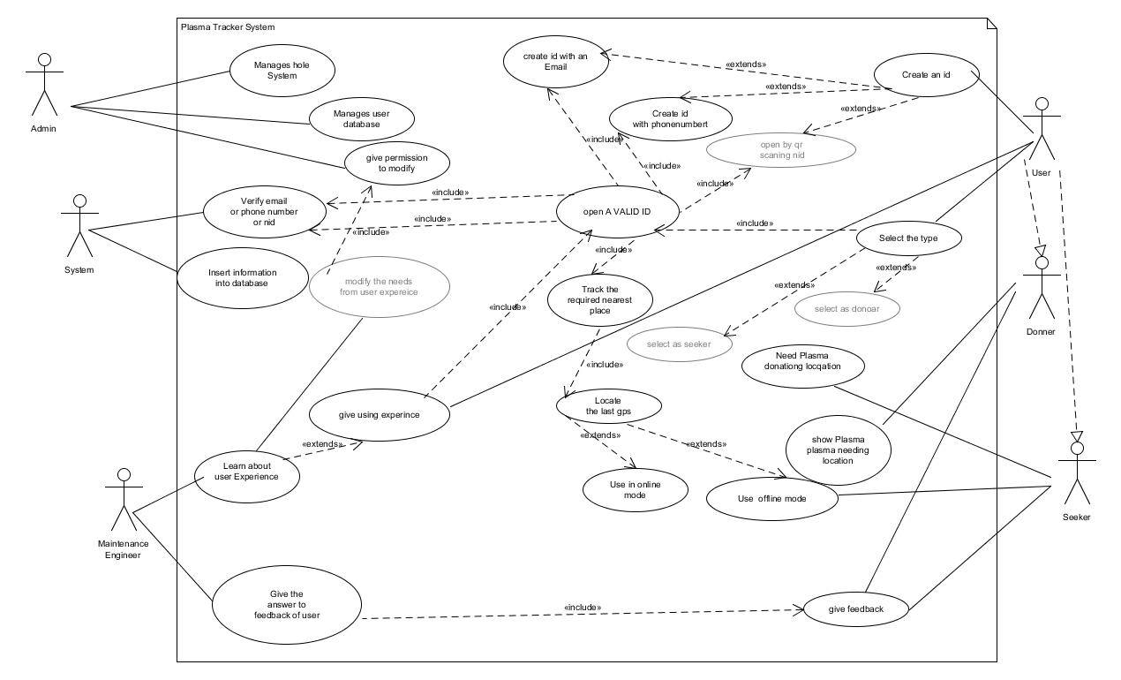

**Figure: Use-case diagram**

**(B) Identify various elements such as classes, member variables, member functions etc.**

**of the class diagram. And, draw the class diagram as per the norms.**

In This Plasma Tracker System, A User must need to create an id with his or her email and phone number or NID to login to this system. After Creating the id User need to select language (It’s not mandatory). Then user will choose himself as donor or seeker. After choosing, if user will donor then he gets the option to donate plasma to seeker location or Plasma bank, Hospital or his information that when seeker will need, they can find him/her, if user will seeker then he will get option of plasma bank or donor location. Seeker can chat directly after he know that this donor has plasma that he needs. All information will store on system database that only access-able by admin. Here Admin actually manage the whole system, he will develop the system, update user’s info on database. Her another one, who have also access to maintain the whole system. He/she is maintenance engineer. Admin will give him or her access to maintain the system. But all the time he needs to permission from admin to update database, develop system function.

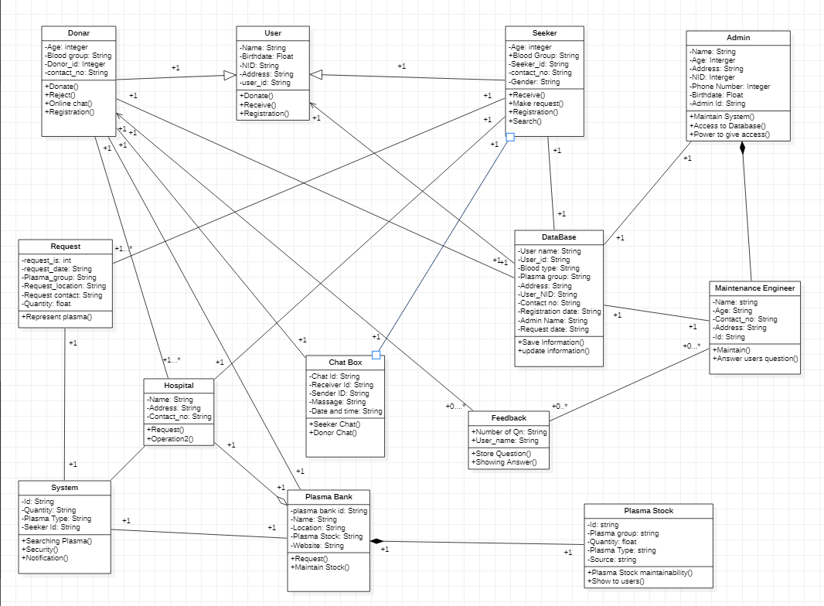

**Figure: Class diagram**

**(C) Identify various elements such as controller class, objects, boundaries, messages etc.**

**of the sequence diagram. And, Draw the sequence diagram as per the norms.**

In plasma tracking system, verify if a user will be able to login with a valid user id and valid password whether a user cannot login with a valid user id and an invalid password. If user id is valid, verify the login page redirection to main page otherwise id will be invalid. Then the field is showing display error and user get the ‘Forgot Password’ functionality. Enter the valid email address, user can be able to enter the login page. After the successful enter user can be able to find the account from database system. Verify database return a ‘code’ functionality to login page. After returning this code, user can easily receive the code from login page. Send verification code to user email from login page. After successful verification code is valid from database system. Verify if the code is correct, a user will be able to login with a new password only after he/she has changed the password. User can easily enter the new password. Then password will be updated in database. If code is valid, verify the login page redirection to main page otherwise code will be invalid and display will be error. User sends logout request to login page. Login page then request database to delete this session

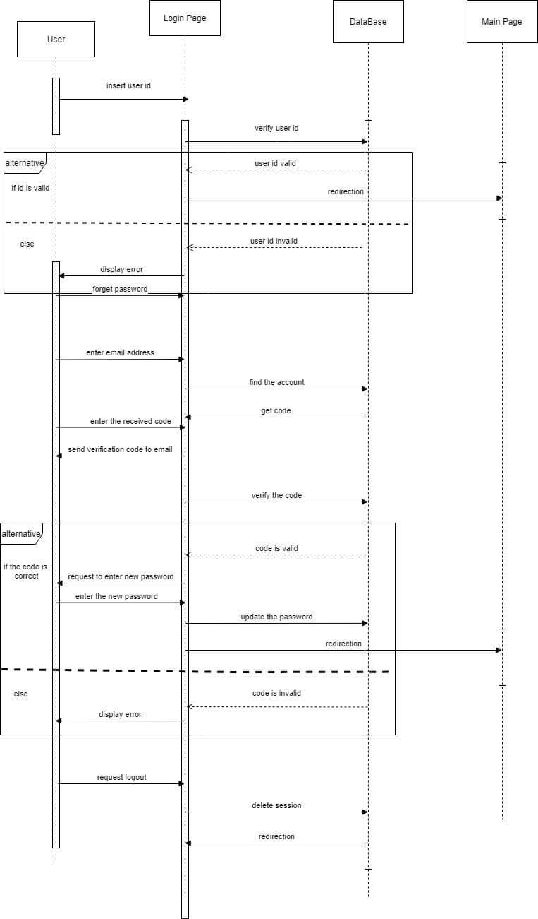

**Figure: Sequence diagram**

**(D) Identify various actions and corresponding events of triggering actions. And, draw**

**the activity diagram as per the norms.**

In plasma Tracker System, A user can open his/her an account for donating or seeking the plasma. First the user will request to create an id then the system checks if the user gave a valid phone number or valid email if the email or phone is not valid the system wants scan the user Nid to open an account. If user fails to give valid Nid the system will start from the beginning. If the phone number or email is valid then There a notification sent to the email/phone number and the verified account will created simultaneously. If account status is open the system will check what is the user needs. If the user needs to seek the plasma then he will get option of the nearest place to collect the plasma then system will check if the user is online mode or off linemode. If the user is in the online mode then there is the GPS tracker that locate the places if the seeker is offline mode the it will show the last location selected by the user. The donor will search for the place where the plasma is needed.

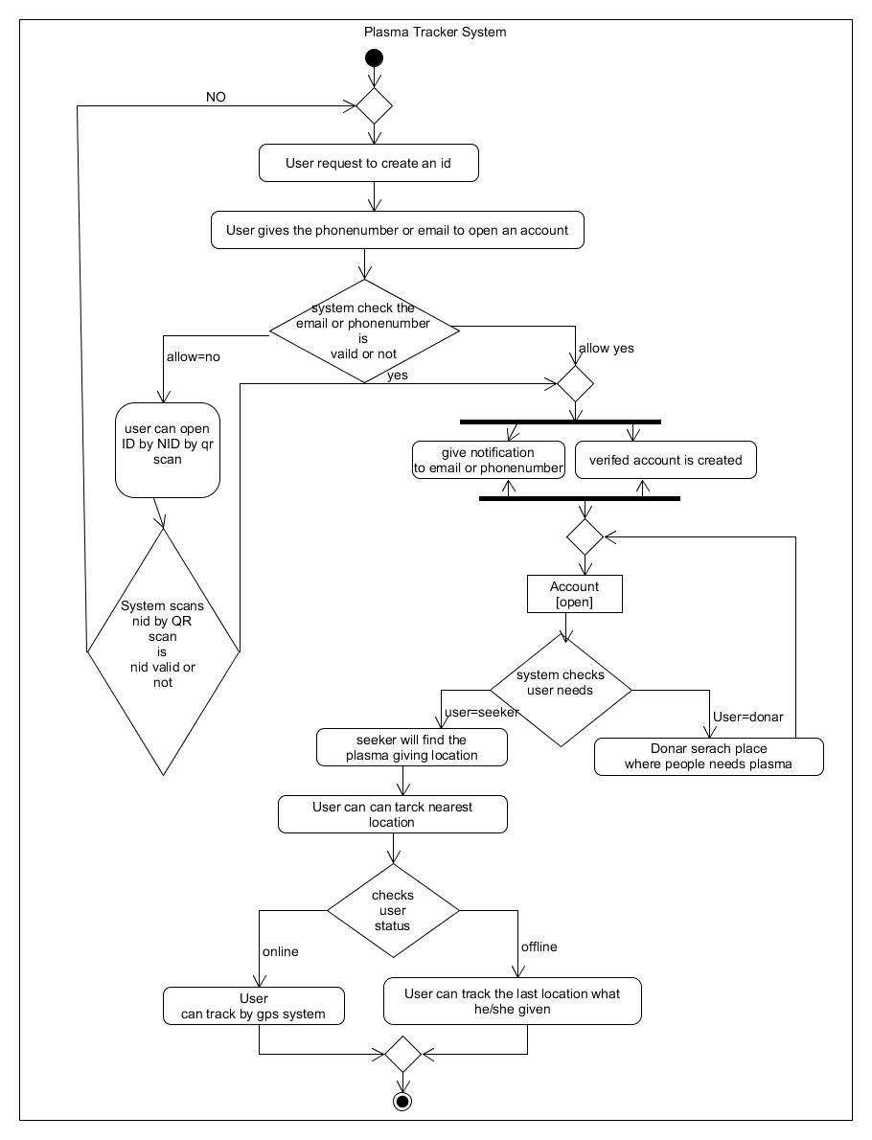

**Figure: Activity diagram**

**Evaluation: Your Design Specification must address the following questions:**

**1. Does the use case narrative represent the Scenario of the use case diagram? Does the Use**

**Case diagram include the major use cases, actors who perform the use cases and the**

**relationships among the use cases needed to deliver by the system?**

There are some rules to draw a use case diagram There will be actors and use cases. There will a relation between actors or there will be some relation between use case. For the relation use case if one is need to done before starting the next, we use a keyword call includes and if there some optional task which will perform after the main task is done. The actors should be in noun form and the use cases will be verb form. As we draw the use cases of the system, we follow all the rules to draw a basic use case diagram of the system. There are five actors in the system and some actors have some common use cases as we see in the system and we also give the relation of task perform. So, in our opinion we follow all basic rules of the use case diagram to modify then the maintenance engineer can modify.

**2. Does the class narrative represent the Scenario of the class diagram? Does the Class**

**diagram include the major classes (attributes, operations) and the relationship among the**

**classes needed to deliver by the system?**

This Class diagram designed by Studying case and using all following rules. So now we see that there are some class which are needed to make this diagram. Here User class have to two Inheritance class (Donor and Seeker). Total thirteen class used to design this class diagram. When seeker request for plasma, then request class call system to find out plasma info for seeker. System Class start to find plasma by searching hospital class or plasma bank. If Bank or hospital has stock of plasma then Send to seeker. Seeker class directly chat with donor by using chat. Admin mainly control whole system. Maintains engineer do rest of work in system, but he has not access to use database but sometimes admin give access the system data base to Maintain engineer to maintain the system. This Class diagram show all the task performance and all the basic need for user to use system.

**3. Does the activity narrative represent the Scenario of the activity diagram? Does the**

**Activity diagram include the major activities needed to deliver by the system?**

The activity Diagram which is drawn by case study is followed all the rules. So, we see that there some states, Decision boxes and status of system which are needed to draw an activity diagram. As we draw with major activities of the system and which is the needs of the user. The System contains with some Decision making which will face the user when he/she is using the system. Firstly, it starts with state where user wants to create an id then the he/she will give the email or phone number to the system the Decision box will check the validation of the system. So, after verifying, there are two things will happen simultaneously. After that there is status where the system has a status and that is account open. the rest decision will happen one after another has describe that this system is mainly use for donate or need the plasma from the user so this activity Diagram is showing all the basic needs of the user in this system

**4. Does the sequence narrative represent the Scenario of the sequence diagram? Does the**

**Sequence diagram include the sequence of the major activities needed to deliver by the**

**system functionalities?**

The Sequence Diagram Show that the User verification, login process of the system.  
1st of all user needs to open a valid id to use this system, if user use non valid id and password then he or she or user can’t login in this system. And if it is valid then user need to verify the login page. If user can’t then id will be disable. If user forget password then user can reform his password. By using valid mail id, and system will generate a random code and it will send user by a mail. After successful verification user will change his/her password. If fail then system will go back to home page. Everything will be saved in database system. It’s all the functional system that help to user how to use this system.

**EXERCISE - 4: Selection of Process Model**

**EXERCISE - 4: Selection of Process Model**

**Objective: Selection of appropriate process model for the software development**

**Tools/ Device: Protégé Ontology Development tool to check rational and consistency of your**

**process model selection.**

**Procedure:**

**1. Study the Software Engineering process model to appropriate process model to develop your proposed system solution.**

The software engineering process model has so many development models that can be utilized to develop a software. For the software named Plasma Tracker Agile development process model is appropriate since it’s fulfilling the criteria that are needed by the software. Agile process model contains flexibility, it is a state of dynamic, adapted to the specific circumstances. This software development refers to software development methodologies centered round the idea of iterative development, where requirements and solutions evolve through collaboration between self-organizing cross-functional teams.

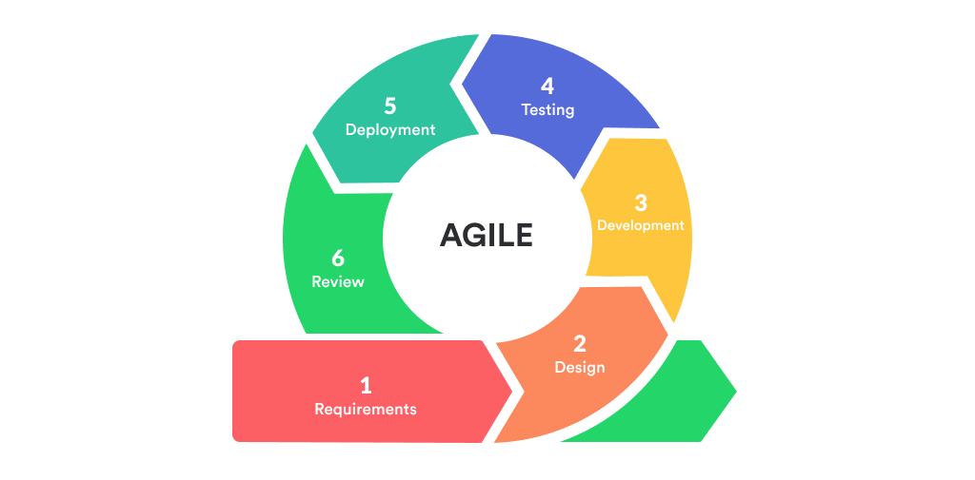

**Figure: Agile development process model**

The ultimate value in Agile development is that it enables teams to deliver value faster, with greater quality and predictability, and greater aptitude to respond to change. This process model (Agile process model) best suited for the application where the requirements change rapidly during the development process.

**2. Present your arguments based on your analysis about why your selected method(s) is the best choice among all other methods to develop your proposed software.**

Developers use the agile development process model to minimize risk such as bugs, cost overruns, and changing requirements when adding new functionality which are beneficial terms for the project Plasma tracker. In agile development process model methods, developers develop the software in iterations that contain mini-increments of the new functionality. There are many different forms of the agile development method, including scrum, crystal, extreme programming (XP), and feature-driven development (FDD). It suits small-medium size projects like the project Plasma Tracker, with rapid changes in the requirements as customers are involved during each phase. Very limited planning is required to get started with the project. It helps the company in saving time and money (as result of customer physical interaction in each phase).

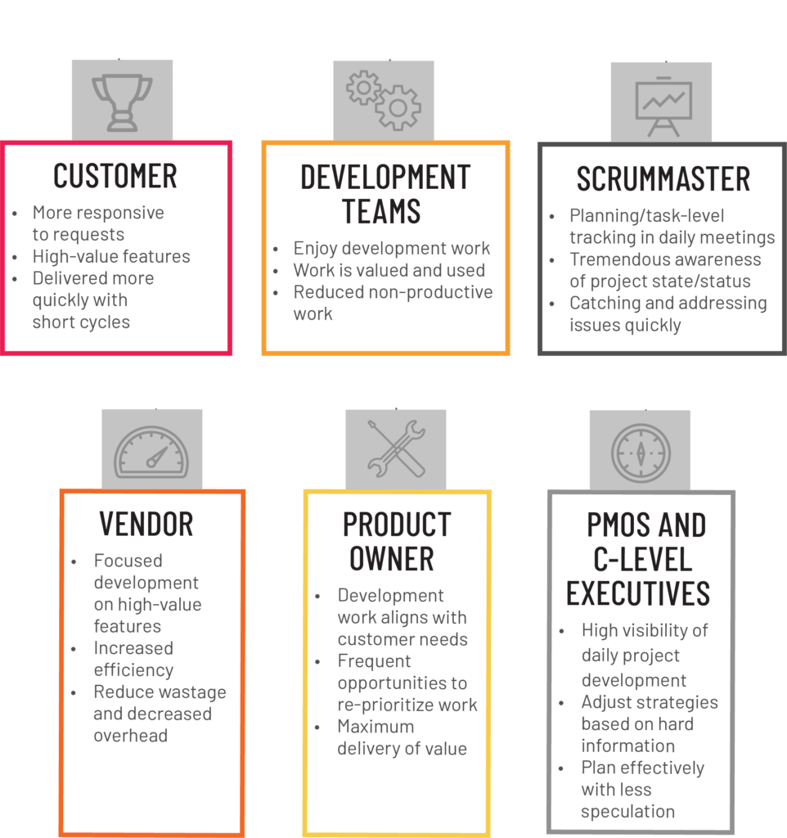

The implementations or daily develop mentation make it possible to measure productivity. The primary benefit of agile software development is that it allows software to be released in iterations. Iterative releases improve efficiency by allowing developers to find and fix defects and align expectations early on that helps to connect more users for the application. They also allow users to realize software benefits earlier, with frequent incremental improvements.

Other development process models like waterfall development model, V-model, Iterative development model, Incremental development model, Rapid action development method contain slow and costly due to its rigid structure and tight controls. These drawbacks can lead these methods users to explore other software development methodologies. And those require stable developer composition with highly skills and users who are deeply knowledgeable about the application area. Deep knowledge is essential in a condensed development timeline that requires approval after each construction phase. Even in light of its benefits, there are a few drawbacks in all those other development process methods.

Though the Agile process model is difficult to scale up to large projects where documentation is essential. But analyzing among all the methods the best choice is Agile process model to develop the software named Plasma Tracker.

**3. Identify all the roles in the project management activities in software development.**

**Describes the responsibilities of the role in the software development.**

**Your Design Specification must address the evaluation rubrics mentioned in the software engineering course outline.**

In the Project name Plasma Tracker various types of rolls in the project management activities can be found depending on their activities which includes projects, estimation of cost in different sectors or steps performance. Based on the project plasma tracker the roles in the project management activities and combined in a additional role call Maintenance Engineer in this project so a list of project management activities in software development is given below with their specification.

**Analyzer and managing Engineer:**

The bigger the project is, the more likely there are to be hurdles and pitfalls that weren’t part of the initial plan. Good analyzer and managing engineer knows how meticulously and almost identify and evaluate potential risks before the project begins. They know how to then avoid risks or at least minimize their impact.

**Developer:** Developer are the heart and soul of the process; the developer actually writes the code that the Development Leads provided specifications for.

**Development Manager:** The Development Manager is responsible for managing multiple priorities of conflicting projects. The Development Manager role is also an escalation for issues from the team, which it is unable to resolve internally. Of course, each organization has its own take on these roles; however, these are the roles you'll see most often in an organization doing development.

**Data miner:** Data miner knows how essential final reports and proper documentation are. Good data miners can present comprehensive reports documenting that all project requirements were fulfilled, as well as the projects’ history, including what was done, who was involved, and what could be done better in the future.

**Functional Engineer:** Functional Engineer have the unenviable task of selecting clear, non-conflicting requirements from the Subject Matter Experts who may or may not understand how technology can be used to transform the business processes in a positive way

**Project Manager:** The Project Manager is responsible for ensuring consistent reporting, risk mitigation, timeline, and cost control. The project manager role is a problem-solver role. They try to resolve problems while they are small so that they can be handled more quickly and with less cost.

**Exercise - 5: UI and UX Design**

**UI Design for the project is given below:**

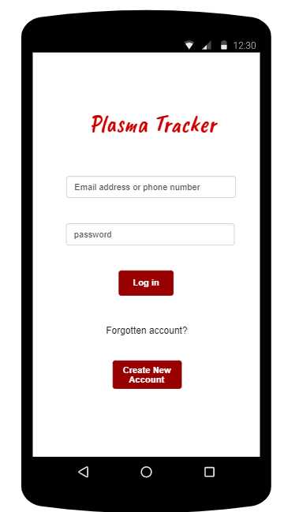

**Figure 5.1**: Homepage

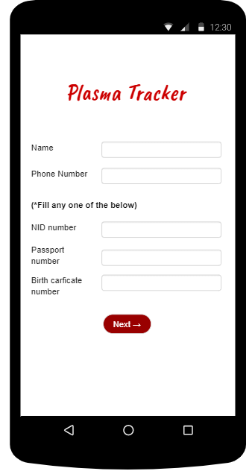

**Figure 5.2:** Create_new_account_page_1

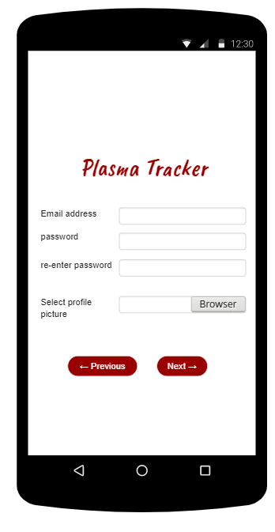

**Figure 5.3:** Create_new_account_page_2

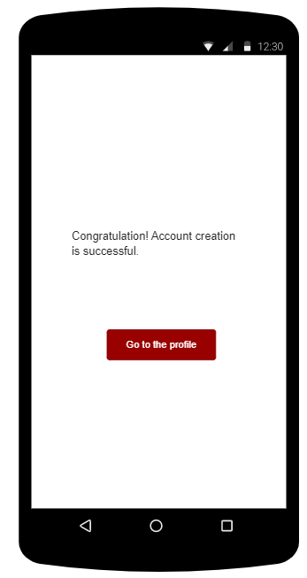

**Figure 5.4:** Create_new_account_page_3

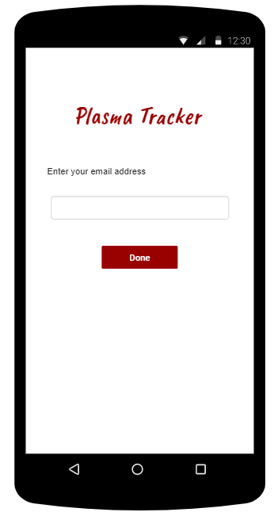

**Figure 5.5:** Forgotten_account_page_1

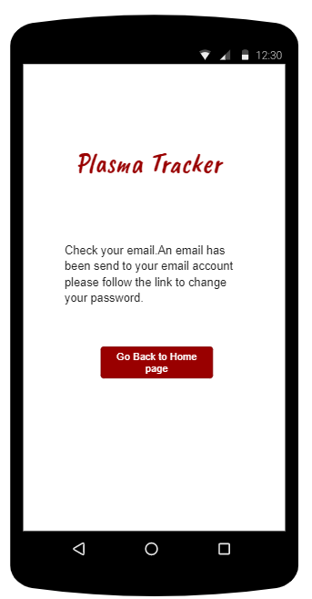

**Figure 5.6:** Forgotten_account_page_2

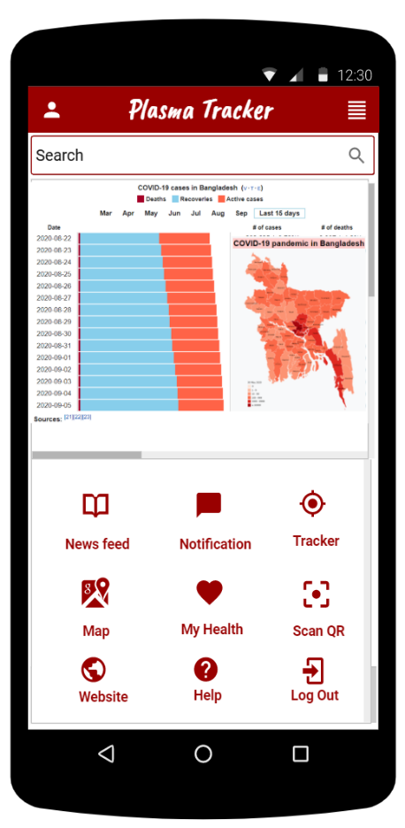

**Figure 5.7:** User Profile

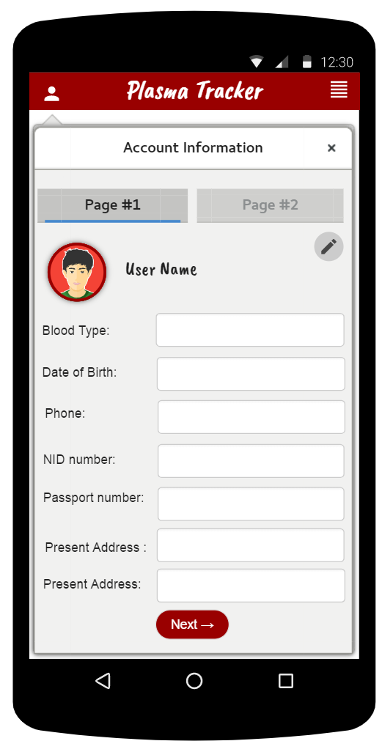

**Figure 5.8:** User account

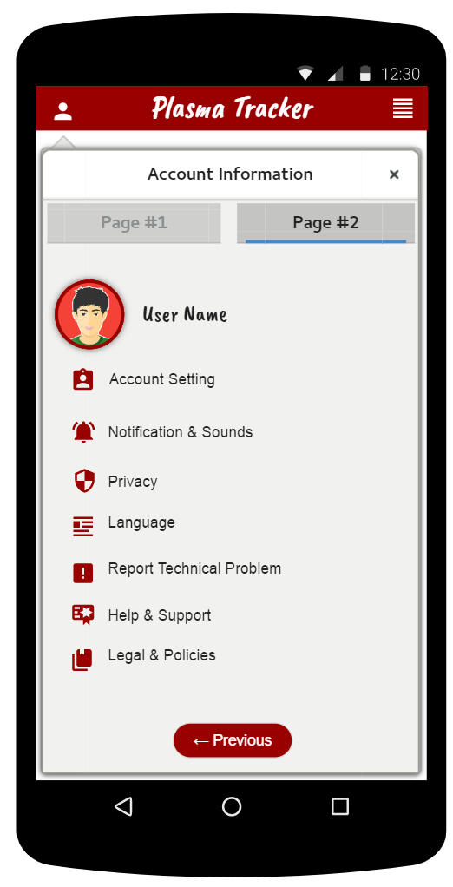

**Figure 5.9:** User_account_page_2

**Exercise - 6: Project Test Planning**

|  |  |  |  |  |  |
| --- | --- | --- | --- | --- | --- |
| Project Name: Plasma Tracker | | | | Test Designed by: Mahiul Alam Sad | |
| Test Case ID: SF_1 | | | | Test Designed date:30/8/2020 | |
| Test Priority (Low, Medium, High):High | | | | Test Executed by: | |
| Module Name: System login Session | | | | Test Execution date: | |
| Test Title: Verification of login with valid username and password    Description: Test Application login Phase. | | | | | |
| Precondition (If any): Account Holder must have valid username and password. | | | | | |
| Test Steps | Test Data | Expected Results | Actual Results | | Status (Pass/Fail) |
| 1.Go to Application login page.  2.Enter User ID.  3.Enter User Password.  4.Click Submit. | User ID: Saad@hotmail.com  User Password:123 | User can Login into the Application. | As expected | | Pass |
| Post Condition: User have to contain a valid user id with a valid password with database to successfully login to his/her account. The account session details are logged in the database. | | | | | |

|  |  |  |  |  |  |
| --- | --- | --- | --- | --- | --- |
| Project Name: Plasma Tracker | | | | Test Designed by: Mahiul Alam Sad | |
| Test Case ID: SF_3 | | | | Test Designed date:30/8/2020 | |
| Test Priority (Low, Medium, High): High | | | | Test Executed by: | |
| Module Name: System Security Session | | | | Test Execution date: | |
| Test Title: Verification of System Security with forget password and ID  Description: Analyzing App System Security . | | | | | |
| Precondition (If any): Account Holder must have valid account with valid E-mail and phone number. | | | | | |
| Test Steps | Test Data | Expected Results | Actual Results | | Status (Pass/Fail) |
| 1. Go to the Application.  2. Click forgotten.  3. Enter valid E-mail or phone number.  4.Use the link that send to the E-mail or the phone number.  5.The link will help the user to change the password. | Mail: User@gmail.com  Code:101010101 | User will get the opportunity to change the old password and will get a new password. | As expected, | | Pass |
| Post Condition: User given E-mail or phone number have to match with the System Database to get the link for changing password. | | | | | |

|  |  |  |  |  |  |
| --- | --- | --- | --- | --- | --- |
| Project Name: Plasma Tracker | | | | Test Designed by: Mahiul Alam sad | |
| Test Case ID: SF_2 | | | | Test Designed date:30/8/2020 | |
| Test Priority (Low, Medium, High): Low | | | | Test Executed by: | |
| Module Name: System Language Session | | | | Test Execution date: | |
| Test Title: Verification of Language Change.  Description: Analyzing Language Changing System | | | | | |
| Precondition (If any): User must have valid account. | | | | | |
| Test Steps | Test Data | Expected Results | Actual Results | | Status (Pass/Fail) |
| 1. Go to the Application.  2. Enter User id and password to login to the user profile.  3.Going to the User account select the Language icon.  4. Select a prefer language. | Language Type:  1.Bangla  2.English | Account holder Should get his/her selected language. | As expected, | | Pass |
| Post Condition: User must have to download the application. And the device has to support the application and also the language. | | | | | |

|  |  |  |  |  |
| --- | --- | --- | --- | --- |
| Project Name: Plasma Tracker  Test Case ID: SF_8 | | Test Designed by: Bornil Mostafa  Test Designed date: 27.08.20 | | |
| Test Priority (Low, Medium, High): Medium | | | | |
| Module Name: Location Tracking | | | | |
| Test Title: Testing the GPS work and show the accurate selected place | | | | |
| Description: Location feature is a GPS system in map that Android or Apple displays top the icon of app's UI to provide the user that user can choose his destination for donating or collecting the plasma in the hospital and the location tracing feature will show the nearest hospital or medical center  Precondition (If any): User has to valid ID. If user seriously want to get a notification from app to ask them to update (so that everyone gets the notification) | | | | |
| Test Steps | Test Data | Expected Results | Actual  Results | Status (Pass/Fail) |
| 1. Search the place  2. show the nearest palace  3. Track the location  distance  4. Provide the last selected location in off line  5. Tittle  6. text | Location tracking Required:  GPS and Map | The tracker should tracker the input that are given via user. | As expected | pass |
| Post Condition: User must contain a device that has GPS and Map features and locations have to be on while using the tracking system and if the user use VPN he/she have to turn it off. | | | | |

|  |  |  |  |  |
| --- | --- | --- | --- | --- |
| Project Name: Plasma Tracker  Test Case ID: SF_7 | | Test Designed by: Bornil Mostafa  Test Designed date: 27.08.20 | | |
| Test Priority (Low, Medium, High): Medium | | | | |
| Module Name: Feedback | | | | |
| Test Title: User will give feedback or comment or give his/her experience for the system | | | | |
| Description: Feedback feature is a interaction tool which will help the developer to learn more about user’s drawbacks and problem from the user itself. Feedback feature gather the information from the user and give them the suggestion of using the system.  Precondition (If any): User should contain a valid ID so that it helps the developer to know which user having problem in which terms specifically. | | | | |
| Test Steps | Test Data | Expected Results | Actual  Results | Status (Pass/Fail) |
| 1. Go to the User account.  2. Select the feedback option.  3. Write the issue (can also add screenshot).  4. Click the Done button  5. Will receive a text of regarding the issue. | Notification Required:  Reply or  Archive | After Submitting the feedback regarding the issue that a user is facing, they will receive text with solution from the application. | As expected | pass |
| Post Condition: User have to provide the specific information so that his/her problem can be solved/She can provide screenshot to give a feedback | | | | |

|  |  |  |  |  |
| --- | --- | --- | --- | --- |
| Project Name: Plasma Tracker  Test Case ID: SF_9 | | Test Designed by: Anika Akter  Test Designed date: 27.08.20 | | |
| Test Priority (Low, Medium, High): High | | | | |
| Module Name: Updates Session | | | | |
| Test Title: verify update session with valid play store account | | | | |
| Description: Test update version so that everyone gets the notification. User Google play or Apple store settings are, then Admin will have to make a web service which returns the number of the newest version.  Precondition (If any): The device has to valid system and it should online. | | | | |
| Test Steps | Test Data | Expected Results | Actual  Results | Status (Pass/Fail) |
| 1. Go to the play store or apple store  2. make a web service  3. returns the newest version | Update Required:  Close app or  Download update | User should go to the play store or apple store | As expected | pass |
| Post Condition: If user seriously want to get a notification from app to ask them to update (so that everyone gets the notification) | | | | |

|  |  |  |  |  |
| --- | --- | --- | --- | --- |
| Project Name: Plasma Tracker  Test Case ID: SF_8 | | Test Designed by: Anika Akter  Test Designed date: 27.08.20 | | |
| Test Priority (Low, Medium, High): Medium | | | | |
| Module Name: Notification Session | | | | |
| Test Title: verify notification session with valid update session | | | | |
| Description: Notification feature is a message that Android or Apple displays top the icon of app's UI to provide the user with reminders, communication from other people on time.  Precondition (If any): User has to valid ID. If user seriously want to get a notification from app to ask them to update (so that everyone gets the notification) | | | | |
| Test Steps | Test Data | Expected Results | Actual  Results | Status (Pass/Fail) |
| 1. Small icon  2. App name  3. Time stamp  4. Large icon  5. Tittle  6. Text | Notification Required:  Reply or  Archive |  | As expected | pass |
| Post Condition: N/A | | | | |